Chassis Type Switching and Detection
The content of this chapter mainly involves switching between different car chassis types using the STM32 controller and performing type checks.

Precautions:
- Ensure that the power supply to the STM32 car controller is normal, and check if the positive and negative connections are correct.
- Please confirm that the controller receiver is inserted before turning on the device. If it is already inserted, you can ignore this step (the USB controller receiver is inserted in the robot at the factory).
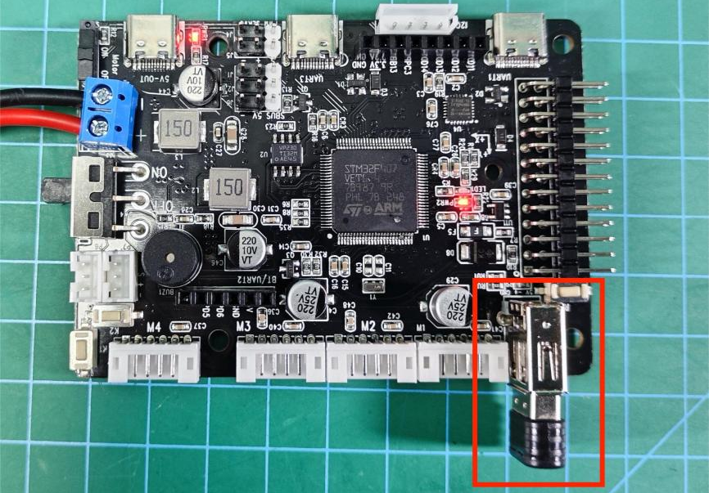

Instructions
Note:
- The control methods for cars with different chassis types will vary. It is necessary to check and verify according to the corresponding car chassis type.
- The car chassis and the two-dimensional pan-tilt mounted on it are both operated via the controller. The operation method for the two-dimensional pan-tilt is universal (right joystick on the controller). For specific details, refer to "3.2 Two-Dimensional Pan-Tilt Control".

2.1 Chassis Switching
On the STM32 car controller, different types of chassis can be switched and detected by pressing the key 1 button (short press) on the STM32 controller and checking the sound emitted by the buzzer on the STM32 controller. The key 2 button (long press) is used to check the current type of car chassis.
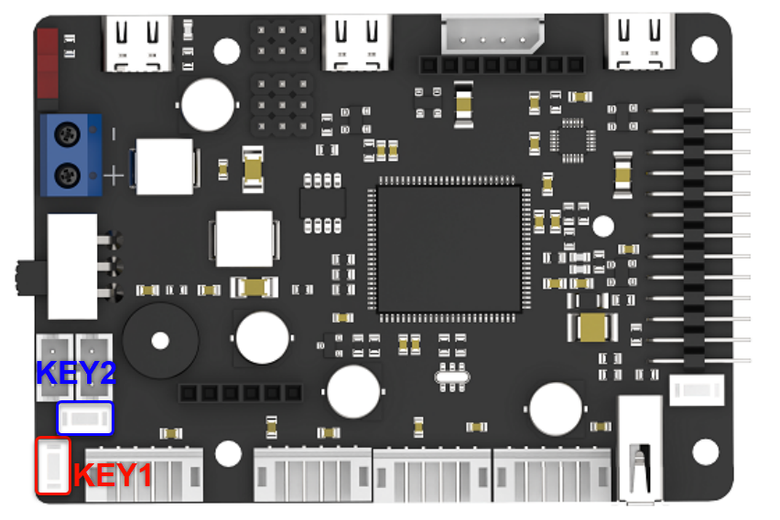
Number of Buzzer Beeps | Chassis Type (Switch by Short Pressing Key1)
1 | Differential（Small）
2 | Track（Small）
3 | Track（big）
4 | Mecanum-wheel
5 | Ackermann（Large）
6 | Ackermann (Small)
7 | Differential（Large）

2.1.1 Differential（Small and Large）
The differential four-wheel car is divided into small chassis and large chassis types. After confirming that the wiring is correct, the control method is the same for both types.
Button | Function | Description
START | Stop and reset the body, then wake up and connect the controller | Press
← | Turn left | Press
↑ | Go forward | Press
→ | Turn right | Press
↓ | Go backward | Press
Left joystick | Go forward | Push forward
Left joystick | Go backward | Push backward
Left joystick | Go left | Push left
Left joystick | Go right | Push right
△ | Graded acceleration | Press
x | Graded reduction | Press

2.1.2 Mecanum-wheel
Button | Function | Description
START | Stop and reset the body, then wake up and connect the controller | Press
← | Turn left | Press
↑ | Go forward | Press
→ | Turn right | Press
↓ | Go backward | Press
Left joystick | Go forward | Push forward
Left joystick | Go backward | Push backward
Left joystick | Turn left on the spot | Push left
Left joystick | Turn right on the spot | Push right
□ | Translate left | Long press
○ | Translate right | Long press
△ | Graded acceleration | Press
x | Graded reduction | Press

2.1.3 Ackermann (Small)
Button | Function | Description
START | Stop and reset the body, then wake up and connect the controller | Press
← | Turn left | Press
↑ | Go forward | Press
→ | Turn right | Press
↓ | Go backward | Press
Left joystick | Go forward | Push forward
Left joystick | Go backward | Push backward
Right joystick | Front wheel turns left | Push left
Right joystick | Front wheel turns right | Push right
△ | Graded acceleration | Press
x | Graded reduction | Press

2.1.4 Ackermann (Big)
The differential four-wheel car is divided into small chassis and large chassis types. After confirming the wiring is correct, their control methods are the same.
Button | Function | Description
START | Stop and reset the body, then wake up and connect the controller | Press
← | Turn left | Press
↑ | Go forward | Press
→ | Turn right | Press
↓ | Go backward | Press
Left joystick | Go forward | Push forward
Left joystick | Go backward | Push backward
Left joystick | Turn left | Push left
Left joystick | Turn right | Push right
△ | Graded acceleration | Press
x | Graded reduction | Press

2.1.5 Track (Small and Big)
Button | Function | Description
START | Stop and reset the body, then wake up and connect the controller | Press
← | Turn left on the spot | Press
↑ | Go forward | Press
→ | Turn right on the spot | Press
↓ | Go backward | Press
Left joystick | Go forward | Push forward
Left joystick | Go backward | Push backward
Left joystick | Turn left on the spot | Push left
Left joystick | Turn right on the spot | Push right
△ | Graded acceleration | Press
x | Graded reduction | Press

2.2 Two-Dimensional Pan-Tilt control (Simple Type and Elevated Type)
If the car is equipped with a two-dimensional pan-tilt, the right joystick of the PS2 controller needs to be used for control, as follows:
Button | Function | Description
Right joystick | Servo NO.1 | Push left and right
Right joystick | Servo NO.2 | Push forward and backward

